SUPPLIER AND PARTS

Display the data from the table suppliers:

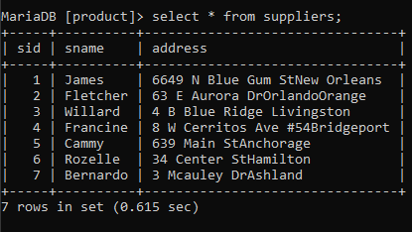

Display the data from the table part:

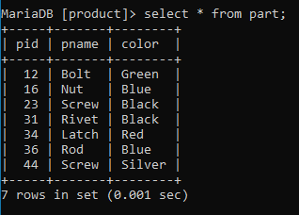

Display the data from the table catalog:

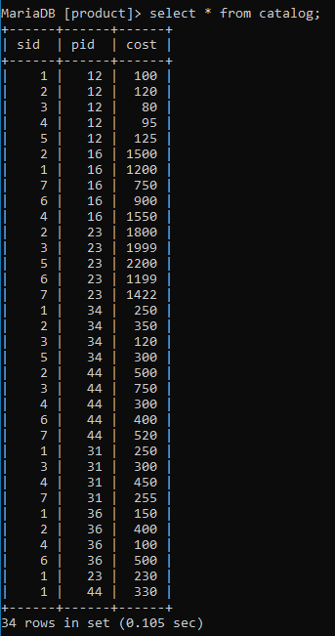

1.Print average cost of parts supplied by all suppliers:

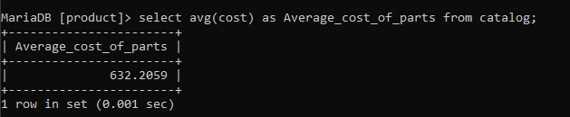

2.Print the name of the supplier and the parts supplied by them:

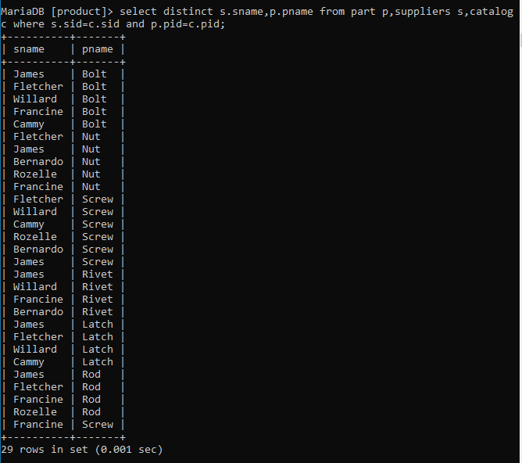

3.Display the count and the average cost of all the parts: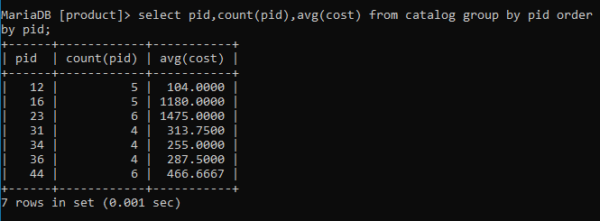

4.Print the parts id,name and color whose name starts with the letter r%:

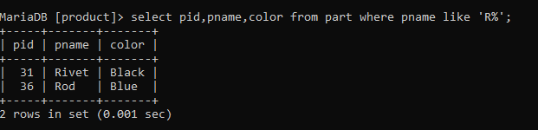

5.Display the count of parts and the average cost of parts supplied from the address 3 Mcauley Drashland :

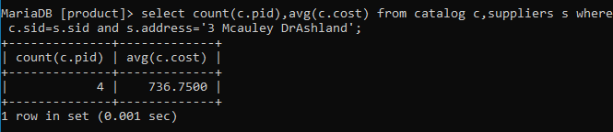

6.Display the supplier name and the cost of the most expensive part supplied by the supplier:

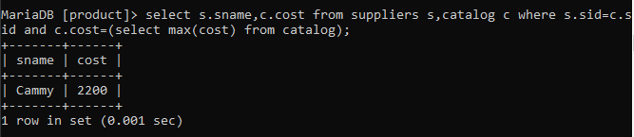

7.Display the part id and cost of the parts supplied whose cost is greater than 500:

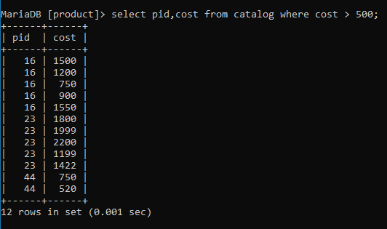

8.Display the part id which is being supplied either in red or green colour:

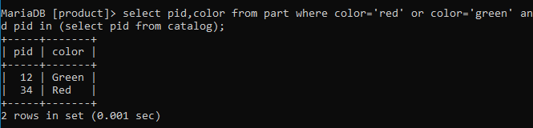

9.Display the average price of blue parts supplied:

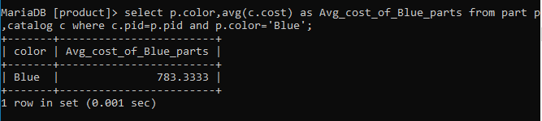

10.Display the number of parts and the average cost for each colour parts that is being supplied:

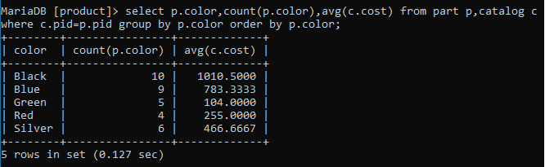

11.For each colour,display the number of parts with that colour:

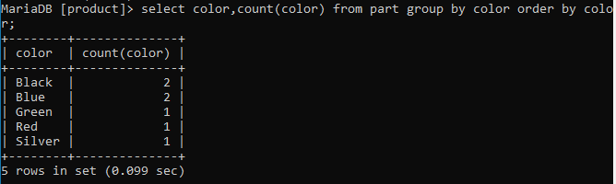

12.Find the number of parts that are not supplied by any supplier:

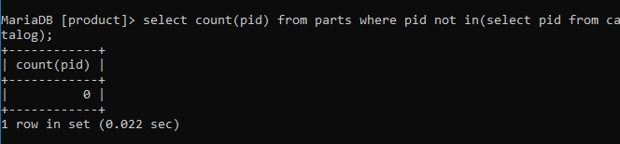

13.For each supplier,Display the part id supplied by that supplier:

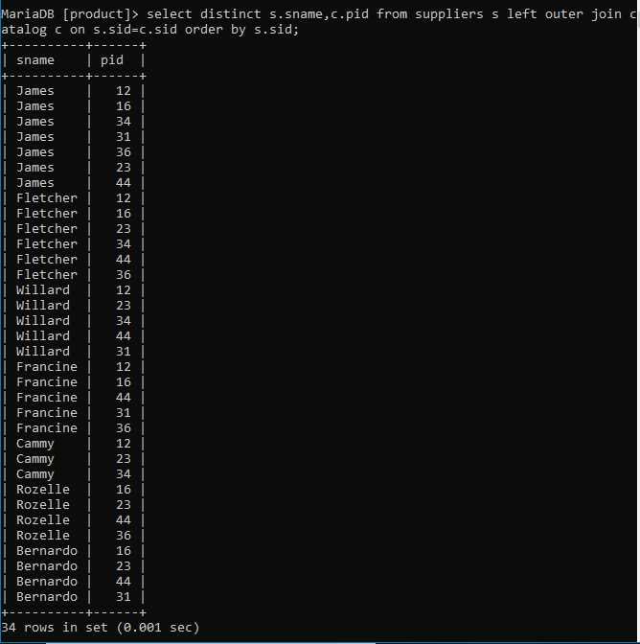

14.Display the names of all parts and colour whose colour starts with the letter B:

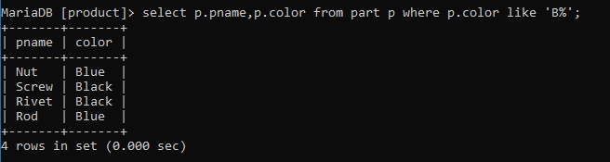

15.Display the total number of blue parts supplied by the supplier:

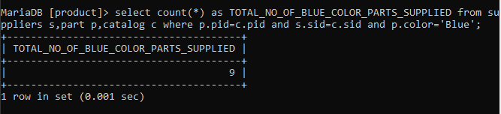

16.Find the supplier id and the supplier name who charges more for some parts than the average cost of that part:

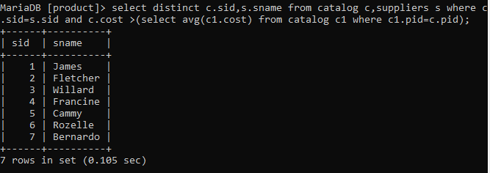

17.Find the name of the part supplied by Fletcher and by no one else:

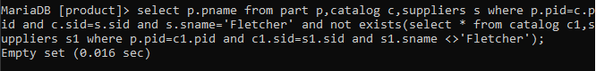

18.Find the supplier name and the address of the supplier who supplies atleast one blue part: 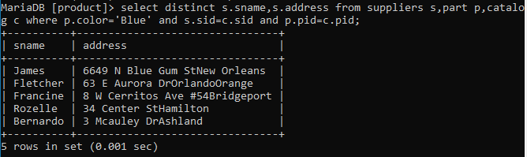

19.Display the name of the suppliers who supply Screw part:

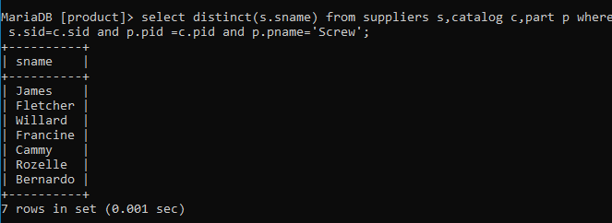

20.Display the supplier name who supplies atleast one of the parts supplied by another supplier:

